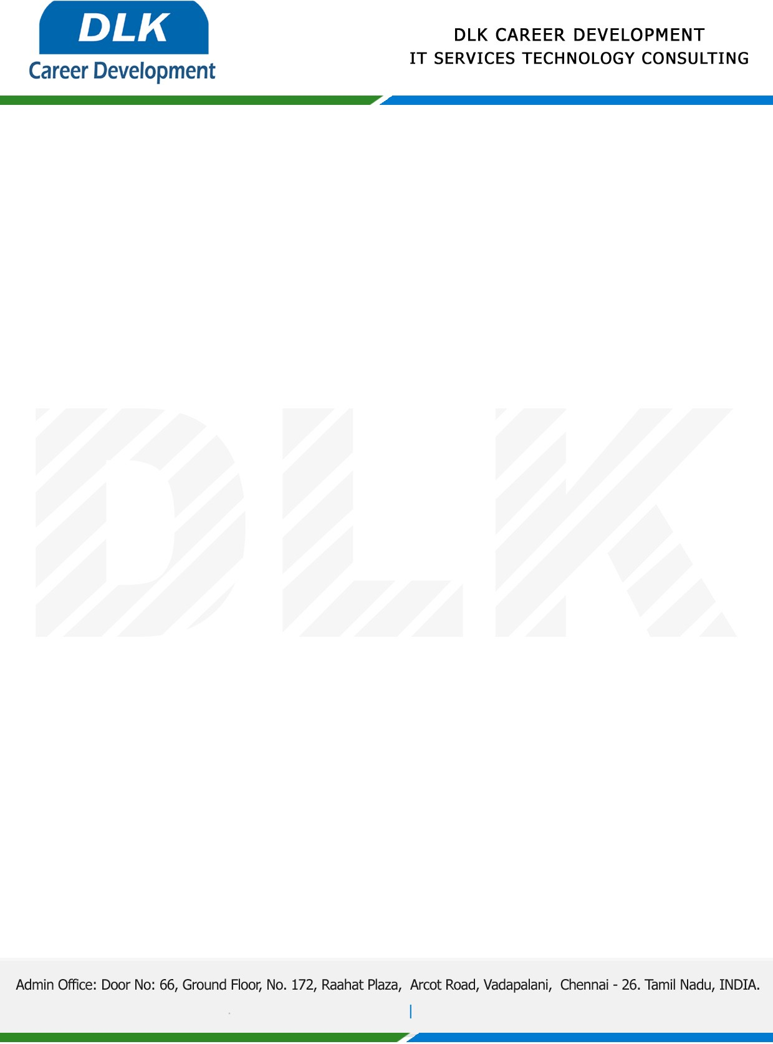

**Date: 28/March/ 2023**

**SUB: INTERNSHIP COMPLETION CERTIFICATE**

This is to certify that **MR Sanjay Siva Sankar G (REG NO:** **2018305519)** of **B.Tech** **(Industrial Biotechnology)**  at **Alagappa College of Technology** has Successfully Completed the Internship Work under the domain of **“Python“** in our organization during the Period **(26th September 2022 to 26th March 2023).**

We appreciate your interest in **DLK CAREER DEVELOPMENT**

**“Best Wishes for Your Future Endeavors “**

For **DLK CAREER DEVELOPMENT**

**HR Manager**

**VELMURUGAN J**